Confined Space Entry | Mirvac Minimum Requirements
- Purpose & Scope
The purpose of this document is to eliminate or minimise the risk of injury when entering and working in confined spaces, so far as is reasonably practicable. The definition of a confined space is as per Australian Standard 2865: Safe working in a confined space.
This document applies to all workplaces under the management or control of a Mirvac entity.
- Minimum Requirements
Mirvac personnel and Service Providers must have processes in place to ensure compliance with:
- the Critical Controls (refer Section 3);
- relevant Forms (refer Section 4);
- all relevant Legislation, Codes of Practice and Standards - including for mobile equipment using public roads (refer Section 7); and
- product guidelines for installation, use or maintenance from the Original Equipment Manufacturer.
- Critical Controls
- Any design, installation, preparation for entry, risk assessment, and work in or on a confined space must comply with Australian Standard 2865: Safe working in a confined space.
- Risk Assessment: Prior to commencing work within a confined space a risk assessment must be conducted. The hierarchy of controls shall be applied in determining the most appropriate method of controlling the identified risks (refer examples in the Hierarchy of Controls Triangles in Section 9). The risk assessment must be conducted by a competent person for all proposed confined space entry work and the results included in the Risk & Opportunity Register prepared for the workplace.
- Design: The design, manufacture or supply of a confined space must ensure that, where practicable, the design eliminates the need for persons to enter the confined space during construction or operations and maintenance. This should be considered during the relevant DOOR workshop. Following the hierarchy of control; the elimination or minimisation for the need to enter any confined space is the first consideration. If elimination is not achievable then the need to enter must be reduced as far as reasonably practicable, including a safe means of entry and exit in the design.
- Register of Confined Spaces: Where a confined space is identified at a workplace, it shall be recorded on the Confined Spaces Register. Temporary control measures such as providing temporary ventilation, or achieving a satisfactory pre-entry gas test, will not cause a confined space to be declassified.
- Further Pre-Entry Precautions: Personnel involved in confined spaces work (including “stand by” personnel) must verify formal training by an approved training provider (RTO with confined spaces in their scope) including rescue and resuscitation skills.
The Isolation Lockout Tagout MMR must be complied with for all energy, services, valves, lines, and switches associated with the confined space.
All possible sources of ignition and combustion must be removed.
- Confined Space Entry: Where entry is required the Confined Space Entry Permit (or its equivalent) shall be completed prior to entry, and entry to the space must only be by trained and competent personnel.
Wherever possible, provide a form of continuous ventilation. Such ventilation is mandatory when carrying out operations which generate potentially hazardous fumes, e.g. cutting or welding. Hot work – e.g. welding, gas cutting, grinding use of drop-saws must use the Hot Work Permit.
- Records for Confined Space Work: The following records will be retained by Mirvac for 10 years:
- Confined Spaces Register for 10 years after being completed.
- Confined Space Entry Permit, or equivalent used by the Service Provider for 10 years after the confined space is returned to normal service;
- Risk Assessment / Job Safety Environment Analysis (JSEA) undertaken by a Service Provider (contractor/supplier) or other workers must be retained for 10 years after the confined space is returned to normal service; or if health surveillance was identified as a requirement records must be kept for 33 years.
- Training records of those Service Providers or other workers involved in the confined space entry including proof of formal accredited training in confined space for each worker involved in the entry and formal training for each worker in the risk assessment and JSEA.
- Emergency Procedures: Emergency planning for incidents relating to confined space rescue must be referenced in the JSEA/SWMS and reflected in the CSE Permit.
- Mirvac Forms
Checklists and Permits are to be completed and then authorised by Mirvac representative prior to work
Confined Space Entry Permit – to be completed before any entry into a confined space.
Confined Spaces Register – to record confined space at the workplace.
Hot Work Permit – to be completed when hot work is performed.
- Roles and Responsibilities
The Mirvac Workplace Manager of each workplace over which Mirvac has control is responsible to ensure workers at the site are aware of and adhere to the performance requirements of this document and responsible to ensure workers are equipped with adequate tools, training, competency and licensing to undertake the work.
- Training and Competency
Minimum Training Requirements for Confined Space Entry
Type of Activity | Required Training
Work at workplace where confined space is present | Confined Space Entry General Awareness Training
Supervising work in Confined Spaces | Confined Space Entry General Awareness Training
Work in Confined Spaces | Full Confined Space Entry Training provided by RTO and including permitting, entry, use of SCBA, use of atmospheric monitoring and emergency planning and rescue
Standby/Rescue for CSE | Full Confined Space Entry Training provided by RTO and including permitting, entry, use of SCBA, use of atmospheric monitoring and emergency planning and rescue
Designers | Confined Space Entry General Awareness Training
- Relevant Legislation, Codes of Practice and Standards
Document Title
NSW: Work Health and Safety Act 2011 (NSW)
Work Health and Safety Regulation 2017 (NSW) Part 4.3 Confined Space
Vic: Occupational Health and Safety Act 2004 (Vic)
Occupational Health and Safety Regulations 2017 (Vic) Part 3.4 Confined Space
Qld: Work Health and Safety Act 2011 (Qld)
Work Health and Safety Regulation 2011 (Qld) Part 4.3 Confined Space
ACT: Work Health and Safety Act 2011 (ACT)
Work Health and Safety Regulation 2011 (ACT) Part 4.3 Confined Space
WA: Occupational Safety and Health Act 1984 (WA)
Occupational Safety and Health Regulations 1996 (WA) Part 3 Division 8
Australian Standard 2865: Confined spaces
WHS Code of Practice – Confined Spaces
Worksafe Australia: Confined spaces
Worksafe Victoria: Compliance code Confined spaces
- Additional Information
Isolation Lockout Tagout MMR
Hot Work Permit
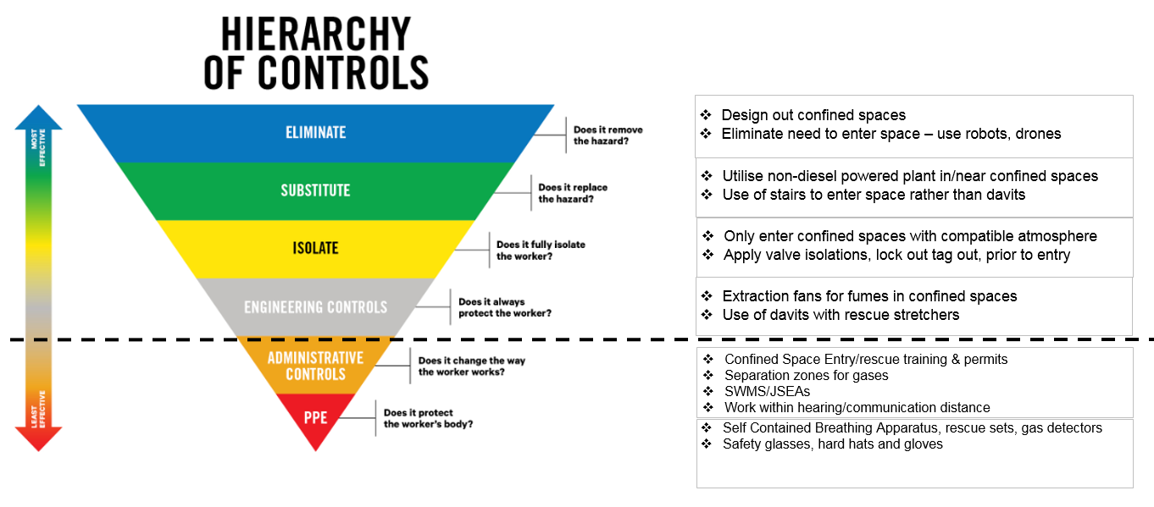
- Hierarchy of Controls Triangle – Confined Space Entry

