Work with Tilt-Up or Pre-Cast Concrete | Mirvac Minimum Requirements

Purpose & Scope
The purpose of this document is to eliminate or minimise the risk of injury when undertaking work with tilt- up or pre-cast concrete, so far as is reasonably practicable.
This document applies to all workplaces under the management or control of a Mirvac entity.

Minimum Requirements
Mirvac personnel and Service Providers must have processes in place to ensure compliance with:
- the Critical Controls (refer Section 3);

- relevant Forms (refer Section 4);

- all relevant Legislation, Codes of Practice and Standards (refer Section 7); and

- product guidelines for installation, use or maintenance from the Original Equipment Manufacturer (OEM).

Critical Controls

- Risk Assessment: All risks associated with the installation and use of precast or tilt-up concrete panels must be identified, assessed and controlled in accordance with the hierarchy of controls (refer examples in the Hierarchy of Controls Triangle in Section 9). The system should ensure adequate controls for the following:
  - protection of workers under and around the structures;
  - prevention of persons falling from height;
  - protection while unloading, placing, securing and bracing panels;
  - management of cranes while lifting and moving panels, including interaction between other cranes;
  - protection of bracing and panels from movements of powered mobile plant and other site activity;
  - the rescue or retrieval of workers or plant specific to the scope of works; and
  - guarding against structural collapse during construction.
- Pre-cast or Tilt-up Design Plan: A design plan certified by a qualified engineer must be provided for the scope of works. As a minimum, the design plan must provide the following details:
  - details of the design and construction of all panels including individual identifiers from each element;
  - design specifications for lifting points and panel placement;
  - details of erection requirements including bracing of the panels and anchorage design details; and
  - details of required inspections for panels, lifting points and bracing prior to, during and after installation (including the frequency of inspections and the methodology for documenting inspection outcomes).
- Documentation: As a minimum, the following documentation must be provided and retained at the workplace where construction works are being undertaken:
  - a copy of the Certificate of Compliance for Design, to certify the design complies with regulations;

  - a copy of Erection Design Certificate of Compliance for Precast Panels certifying the erection design and detailing is in accordance with Australian and Industry Standards;
  - a copy of concrete test reports, relating to the concrete slab or footings to be used for propping purposes (to assure concrete test results are received to the required concrete strength for propping). Unless specifically designated otherwise, the concrete strength of the brace footing or slab, at the time of installation of the propping must be at least 20 MPa;
  - a copy of the Certificate of Load Test and Examination for panel lifting clutches;
  - ensure Manufacturers Certificate of Compliance records (‘birth certificates’) are at the workplace prior to erection, outlining panel concrete strength, date poured, panel weight, lifting insert type, lifting insert anchor type, concrete strength at lifting from cylinder test of panel concrete for panels to be erected;
  - for a mobile crane verification from a geotechnical engineer that, considering the erection detail, the ground surface is stable enough to support the combined weight of the crane and load;
  - where a regional legislative requirement, a copy of any notification to and from a relevant authority responsible for the regulation of concrete element construction work; and
  - a current work plan (as part of the Workplace Risk Management Plan), setting out details of the proposed execution of the work together with a copy of any related information, instructions or diagrams received from the design engineer.
- Structural Design: The structural design of concrete elements must be carried out by a qualified engineer and in accordance with the requirements of AS 3850 Tilt-up construction, AS 3600 Concrete structures and the National Code of Practice for Precast, Tilt-up and Concrete Elements in Building Construction. Refer to the Temporary Works Design & Installation MMR for guidance on the approvals process for Pre-cast and Tilt up design.
The structural design for in-service performance must give consideration to:
  - manufacturing details including element size and reinforcement;
  - erection method of concrete elements which can produce higher loading conditions than the final in- service loads (lifting, rotation and impact can cause variations to load distributions);
  - requirements of the floor slabs to cater for additional construction loads from operating plant and material storage, and for additional loads that can be encountered from topping concrete on some floor slabs and beams that act as formwork; and
  - the stability of the structure prior to tying into the permanent structure.
- Planning: A lift study for the overall activity is required and for dual lift rotation of panels (refer Cranes & Lifting MMR and Plant, Equipment and Tools MMR).
The relevant JSEA/SWMSs are to be developed and submitted for review by Mirvac prior to works being undertaken. The JSEA/SWMSs should address workplace and environment-specific variations to work activities and set out the safe working procedures and must be approved by the Mirvac site supervisor including:
  - protection of workers under and around the panels;
  - prevention of persons falling from height
  - unloading and slinging panels; and
  - cranage requirements for erecting panels into position.

A system must be in place to ensure required hold points are assessed and verified as effective through the various phases of the activity – utilising the Precast Element Lifting Permit.

Permitting (WA only):
  - at least 10 days prior to the casting of any panels, WorkSafe WA must be notified of the event. In addition:
    - notification must occur on the Regulatory form. This applies to panels constructed on site or in a pre-cast yard; and
    - a copy of the WorkSafe WA approval must be supplied to Mirvac.
The approved form must be held on site for the duration of the panel manufacturing and installation period.
- Transportation and Unloading: The pre-caster shall ensure that drivers have been adequately instructed in the safe transportation, loading and unloading of concrete elements including panels.
Prior to transportation the pre-caster must ensure the concrete strength of the precast has reached the design strength for transport and erection.
Concrete elements must be loaded in a sequence compatible with the required unloading sequence. Each concrete element shall be individually restrained from the sides and rear to prevent movement in any direction.
When unloading, individual concrete elements must have as a minimum, a single chain attached and shall not be released until the crane has taken the initial load of that element.
- Lifting and Rigging: The erector is to nominate one person in the erection crew to be responsible for the direction and coordination of the erection sequence. Before erection commences the Precast Element Lifting Permit must be completed for the process / panels to be lifted.
- Bracing and Propping: Temporary bracing and propping systems must be designed by a qualified engineer to resist all expected loads and braced in accordance with the requirements of the shop drawing, including:
  - ensure props to be used are as designed to resist all expected loads including construction loads and “wind loads for temporary structures” in accordance with AS1170.2 Structural design actions - Wind actions;
  - ensure dowel pins and panel bases are fully grouted at least 72 hours prior to props being removed once panel is permanently fixed into position by way of welding or other specified fixing method. All props to be as per propping drawing. All panels to have a minimum of two props unless otherwise designed / engineered. Panel props are not to be removed under any circumstances, prior to written instruction from the erection Design Engineer or Designated Construction Project engineer;
  - all props are to be regularly inspected (in line with the intervals recommended in the Design Plan) for required capacity, damage and to ensure prop pins are secured/locked, and can only be removed by using a tool. The preferred method on a Mirvac project is to install a padlock through the pin;
  - ensure concrete test results are received to the required slab or footing strength for propping. Unless specifically designated otherwise, the concrete strength of the brace footing at the time of installation of the bracing, must be at least 20 MPa;
  - expansion inserts are more susceptible to installation errors than drilled through fixings. A calibrated torque wrench should be used to ensure correct installation torque is achieved when installing expansion anchors and special attention needs to be given to the correct drilling of the holes. An adequate inspection / checking system should be in place to ensure torque wrench is within date and calibrated and expansion inserts are installed correctly; and

  - panel braces must have a permanently fixed identification plate that states the braces load capacity of the brace at its maximum and minimum extensions (WLL in kilo newtons kN).
Note: braces can be erected on concrete of a lower strength providing the concrete slab or footing is specifically designed for the purpose and documented by the erection design engineer. Where there is a risk of interaction between mobile plant and props or concrete sections the appropriate physical barriers, jersey kerbs, wheel stops or similar must be in place to prevent contact with the prop or panel.

- Verification and Inspections: Post erection inspection of pre-cast or tilt up panels and props occurs through the Work Area HSE Inspection conducted by the area Foreman or Supervisor using the Work Area HSE Inspection Form.

- Emergency Procedures: the Workplace manager is responsible to ensure that procedures relating to emergency response following an incident with pre-cast or tilt up concrete panels (e.g. structural collapse, impact with panel or brace and other crane-related incidents) are included in the Workplace Emergency Response Plan.

- Storage: Concrete elements may only be stored in a designated area approved by an engineer and in such a manner as to minimise multiple handling positions. Additioanlly:
  - racking systems, frames and supports must be designed by an engineer for the shape, size and weight of the concrete element;
  - approval and written instructions must be obtained from the engineer before a concrete element is stored horizontally;
  - approval and written instructions must be obtained from the engineer before a concrete element is stored on a suspended floor slab or beams. This is particularly important in a situation where it becomes necessary to put a concrete element into unplanned temporary storage. For example, where the erection of a concrete element to the temporary braced condition cannot be finalised. If approval by an engineer cannot be obtained, the concrete element must be returned to ground level; and
  - during storage, care must be taken to minimise the likelihood of impact between the concrete elements. Where concrete elements are stored in areas of vehicular movement, protection by way of bollards or other physical barriers and appropriate warning signs should be provided.

Mirvac Forms

Checklists and Permits are to be completed and then authorised by Mirvac representative prior to work
Precast Concrete Element Guidance Flowchart – provides sequential guidance for work with pre-cast and tilt-up | Precast Element Permit - utilised to ensure required hold points are assessed and verified as effective

- Roles and Responsibilities

The Mirvac Workplace Manager of each workplace over which Mirvac has control is responsible to ensure workers at the site are aware of and adhere to the performance requirements of this document and responsible to ensure workers are equipped with adequate tools, training, competency and licensing to undertake the work.

Training and Competency

Minimum Training Requirements for Excavation & Trenching
Type of Activity | Required Training
Lifting and Placement of Panels (single lift) | High-Risk Work Licence in Basic Rigging
Lead dogman for Lifting and Placement of Panels (dual lift) | High-Risk Work Licence in Intermediate Rigging

- Relevant Legislation, Codes of Practice and Standards

Document Title
NSW: Work Health and Safety Act 2011 (NSW)
Work Health and Safety Regulation 2017 (NSW) (including Part 3.1 (regs 32-38), Division 3.2.1 (reg 39), Division 6.3.2 (regs 291, 299-303))
Vic: Occupational Health and Safety Act 2004 (Vic)
Occupational Health and Safety Regulations 2017 (Vic) Part 3.5, Plant
Qld: Work Health and Safety Act 2011 (Qld)
Work Health and Safety Regulation 2011 (Qld) (including Part 3.1 (regs 32-38), Division 3.2.1 (reg39), Division 6.3.2 (regs 291, 299-303))
ACT: Work Health and Safety Act 2011 (ACT)
Work Health and Safety Regulation 2011 (ACT) (including Part 3.1 (regs 32-38), Division 3.2.1 (reg39), Division 6.3.2 (regs 291, 299-303))
WA: Occupational Safety and Health Act 1984 (WA)
Occupational Safety and Health Regulations 1996 (WA) Part 3 Division 9 Subdivision 1 – Tilt-up concrete and precast concrete elements
Safe Work Australia: National Code of Practice for Precast, Tilt-up and Concrete Elements in Building Construction 2016
Work Health and Safety Queensland: Tilt-up and pre-cast construction Code of Practice 2003
AS 3850.1 Prefabricated concrete elements – General requirements
AS 3850.2 Prefabricated concrete elements – Building construction
AS 3600: Concrete Structures
AS 2550 Cranes, hoists and winches - Safe use set – General requirements
AS/NZS 1170.2 Structural design actions - Wind actions

- Additional Information

Cranes & Lifting MMR
Temporary Works - Design an Installation MMR Plant, Equipment and Tools MMR

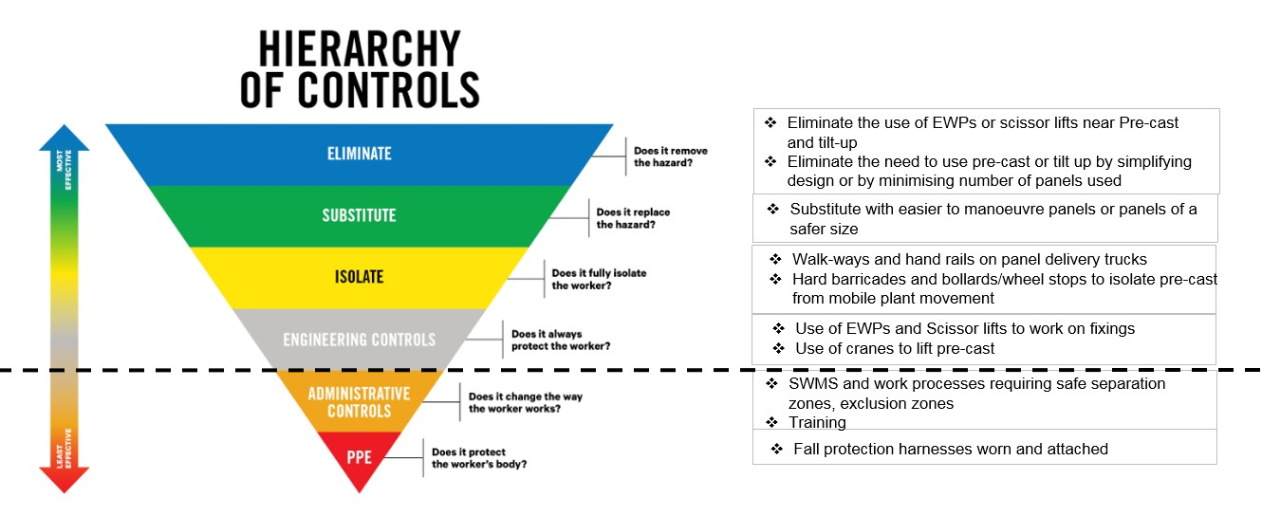
- Hierarchy of Controls Triangle

